**Lab 2 Enable Versioning on the bucket**

1. Sign into the AWS Management Console and open the Amazon S3 console at<https://console.aws.amazon.com/s3>.
2. Click **Create Bucket**.

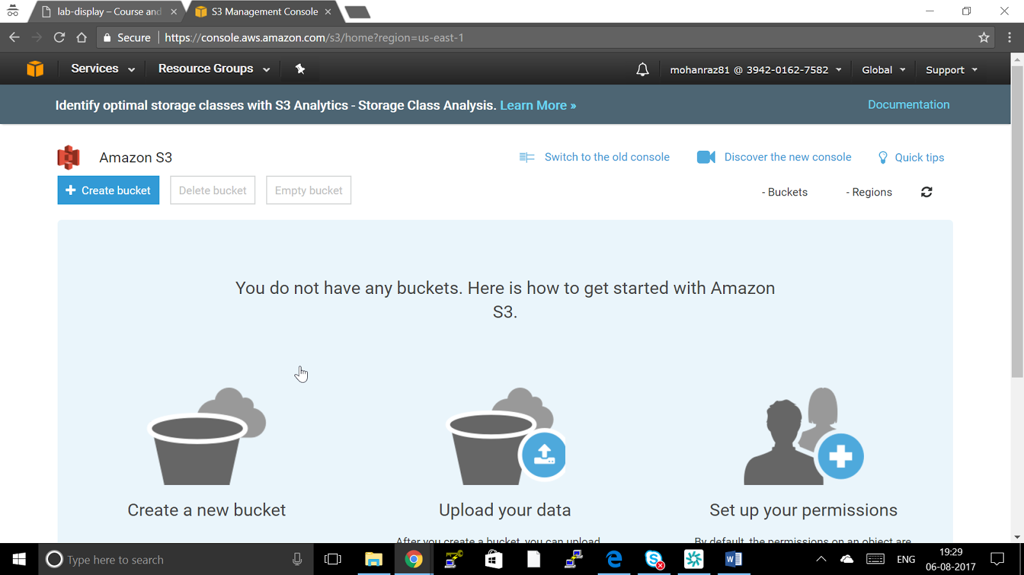

1. In the **Create a Bucket** dialog box, in the **Bucket Name** box, enter a bucket name.

The bucket name you choose must be unique across all existing bucket names in Amazon S3. One way to help ensure uniqueness is to prefix your bucket names with the name of your organization. Bucket names must comply with certain rules. For more information

Bucket name in Course and Labs should follow this guideline USERNAME-REGION NAME-UNIQUE NAME OF THE BUCKET for example mohanraz81-us-east-1-testbucket

* Bucket names must be at least 3 and no more than 63 characters long.
* Bucket names must be a series of one or more labels. Adjacent labels are separated by a single period (.). Bucket names can contain lowercase letters, numbers, and hyphens. Each label must start and end with a lowercase letter or a number.
* Bucket names must not be formatted as an IP address (e.g., 192.168.5.4).
* When using virtual hosted–style buckets with SSL, the SSL wild card certificate only matches buckets that do not contain periods. To work around this, use HTTP or write your own certificate verification logic.

**Note**

After you create a bucket, you cannot change its name. In addition, the bucket name is visible in the URL that points to the objects stored in the bucket. Ensure that the bucket name you choose is appropriate.

1. In the **Region** box, select a region. For this exercise, select **your Allocated Region** from the drop-down list.
2. Click **Next**.
3. To Enable version Click on Versioning

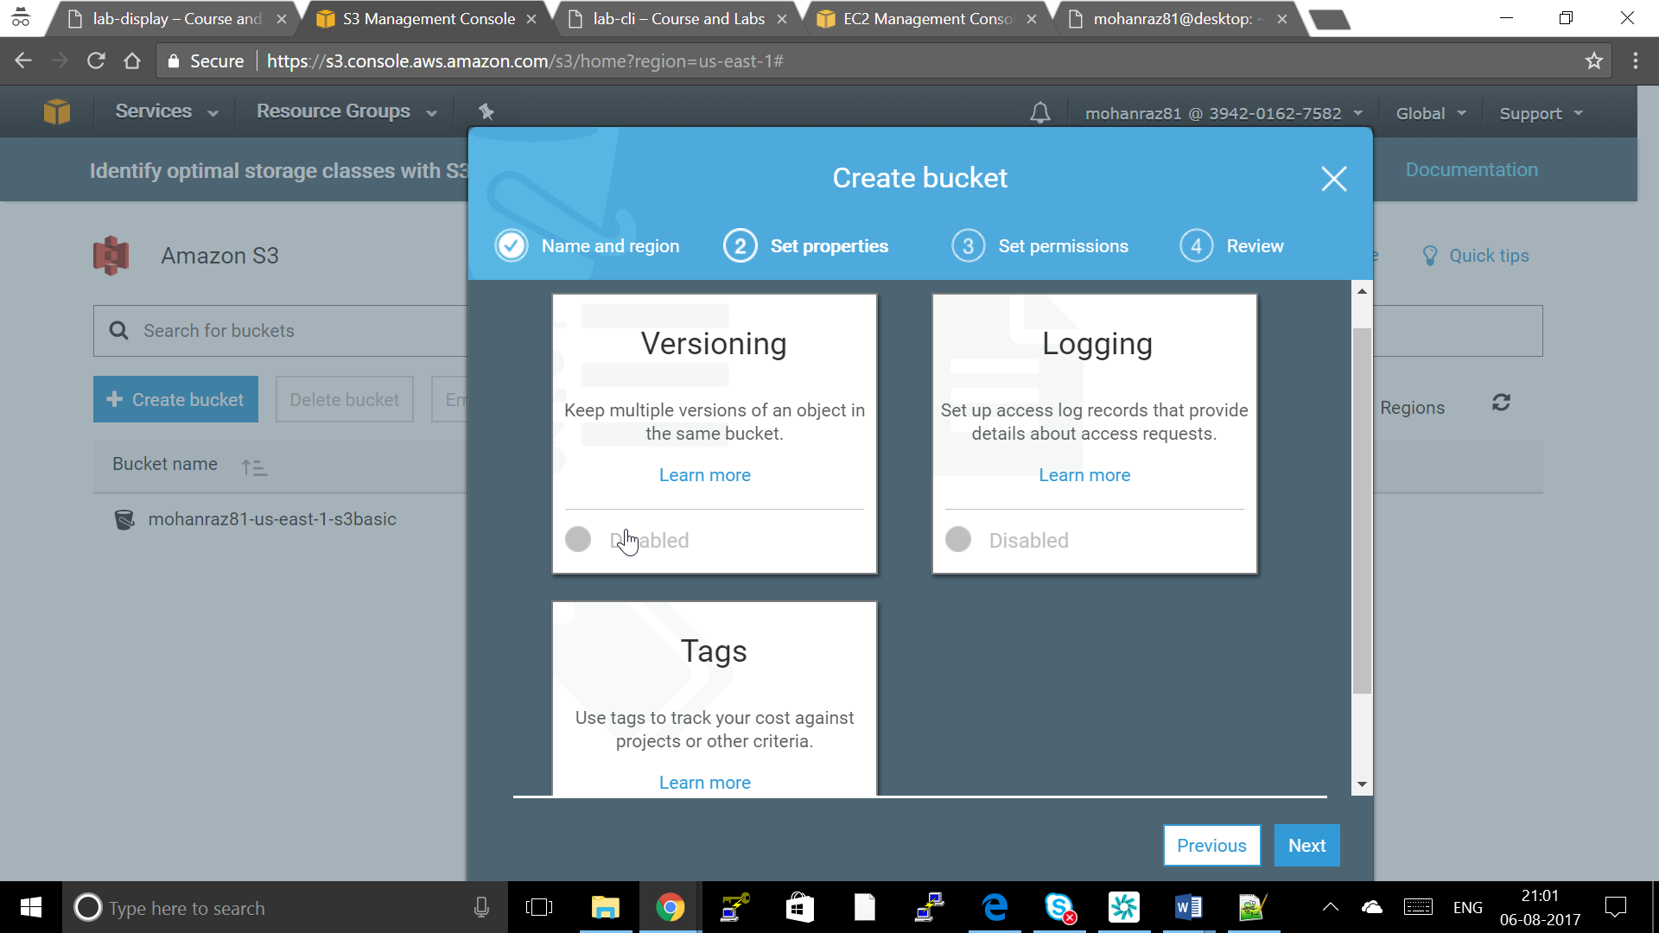

1. Click EnableVersioning and Save to Enable Versioning

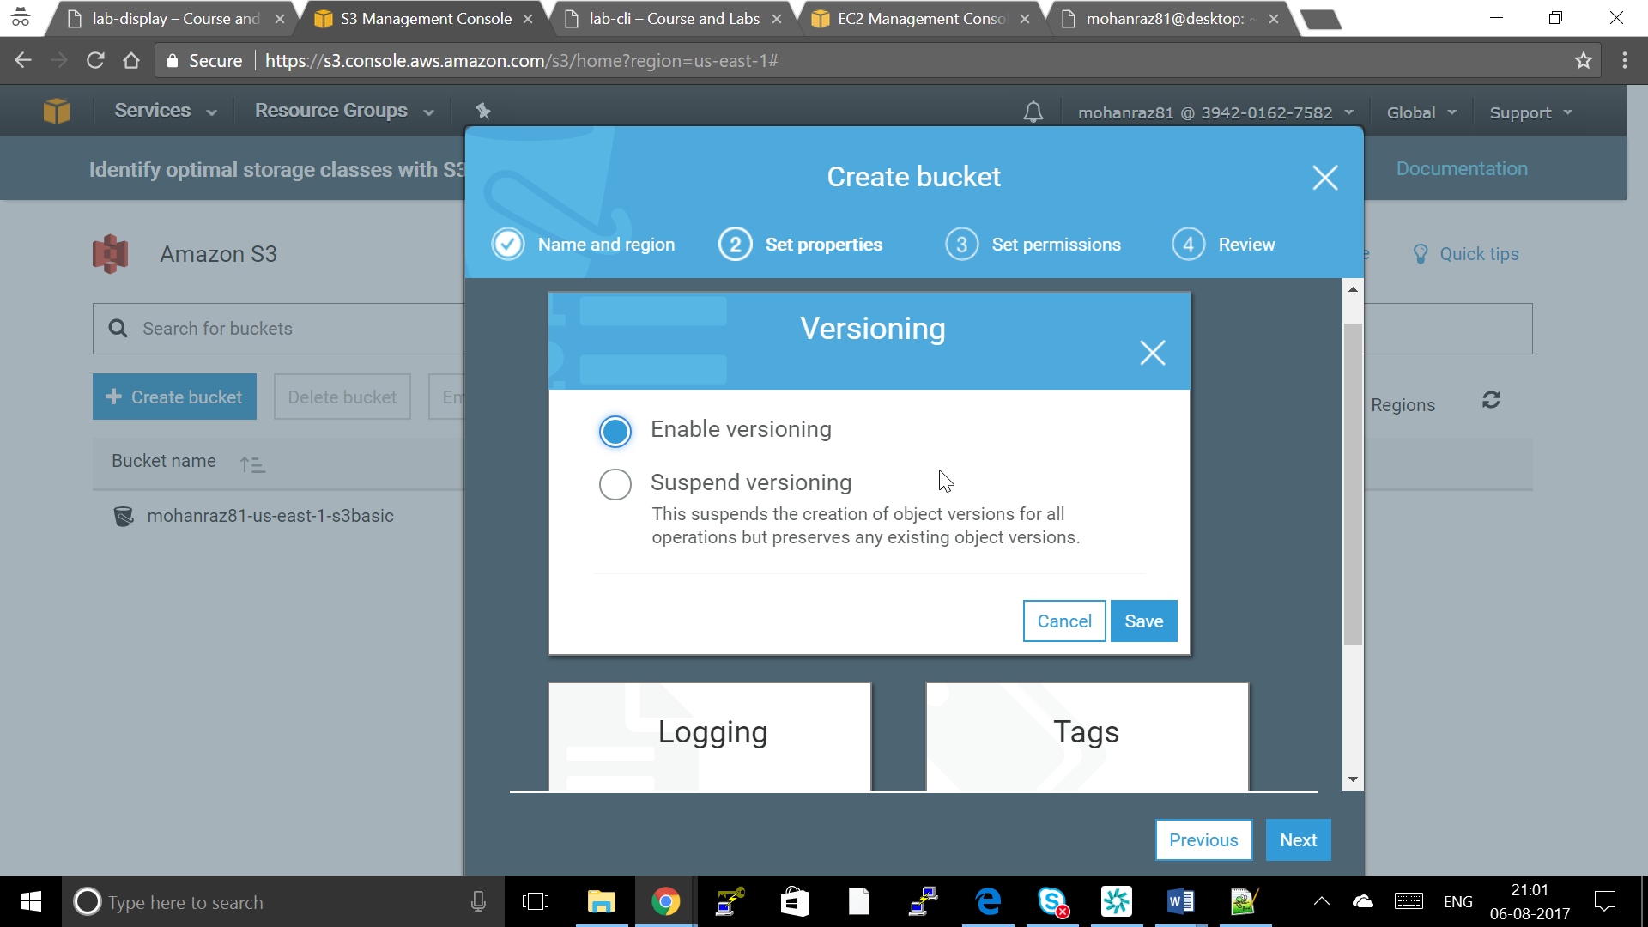 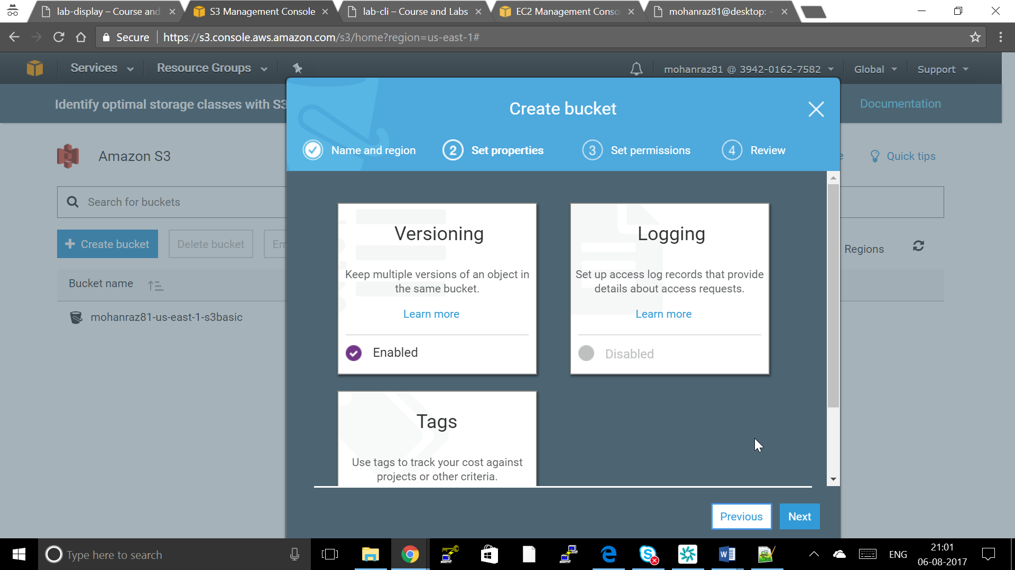

1. Upload a File Once and Chage the File and Upload the file again
2. To View the Versions of the file Click on the File and drop down Latest version

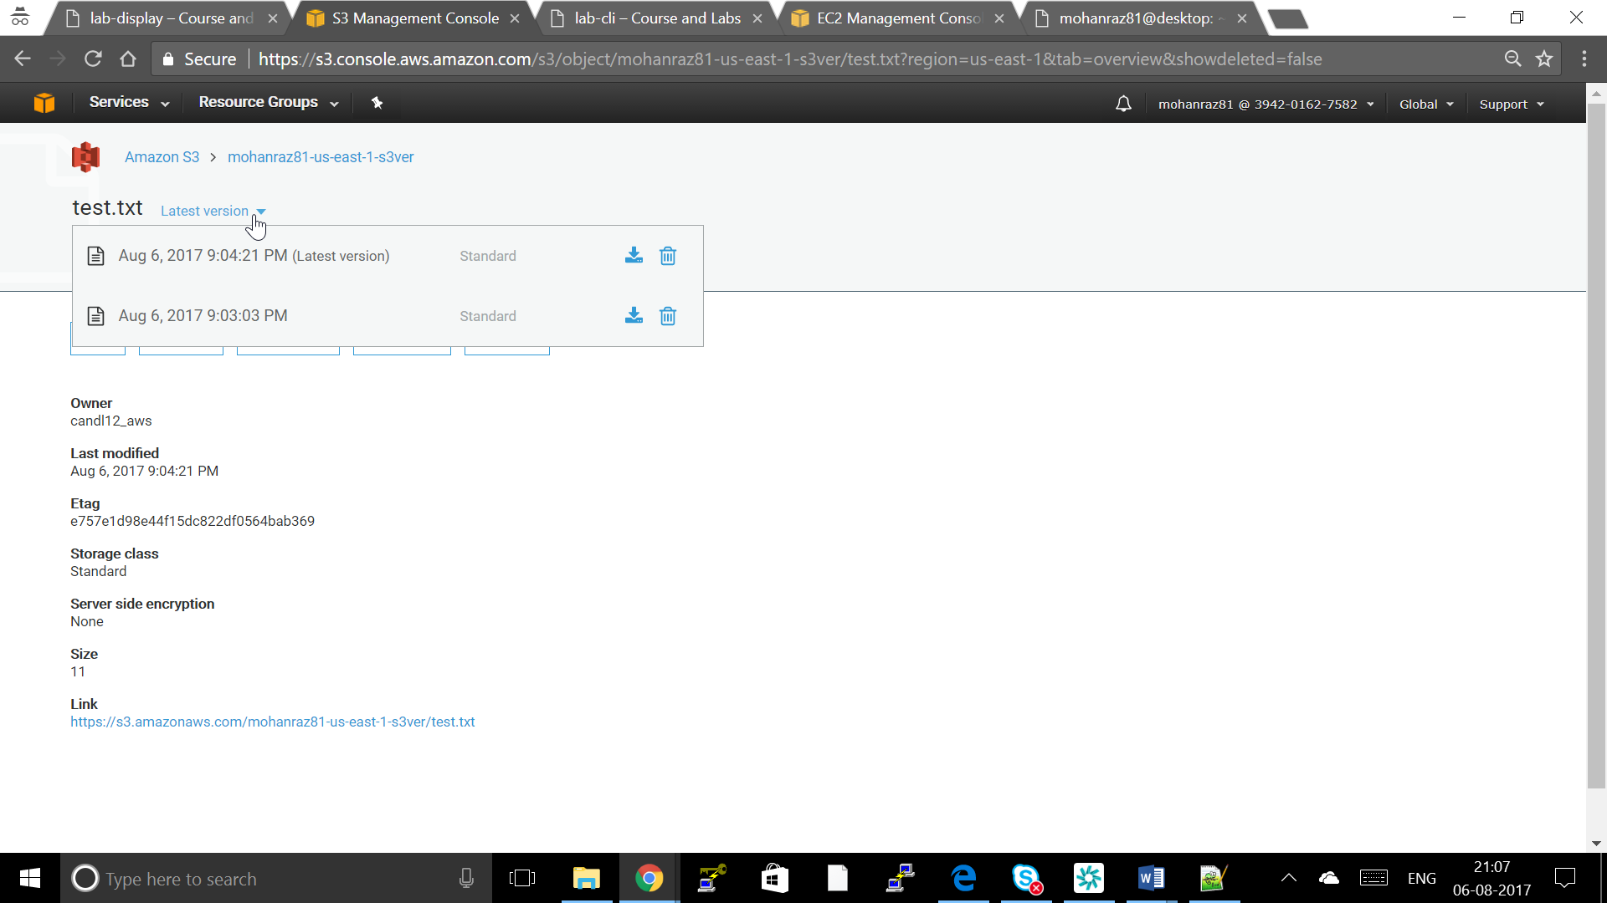

**CLI for enabling S3 versioning for the bucket**

Create a bucket follow Lab1 and execute below command to Enable versioning

aws s3api put-bucket-versioning --bucket my-bucket --versioning-configuration Status=Enabled